Q1) /* If a four-digit number is input through the keyboard,
write a program to obtain the sum of the first and last digit of this number.
*/
#include<iostream>
using namespace std;
int main()
{
int num,sum=0;
cout<<"Enter a 4 digit no : ";
cin>>num;

sum=num / 1000 + num % 10; //with num%10 we get last digit
//with num/1000 we get first digit
cout<<"Sum is : "<<sum;
}

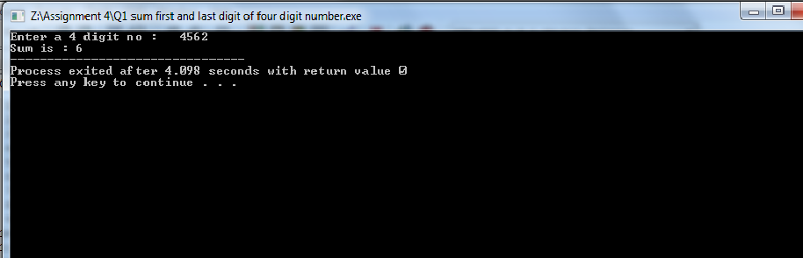

Q2) /*In a town the percentage of men is 52 the percentage of
total literacy is 48 if total percentage of literate men is
35 of the total population write a program to find the
total no of the literate men and women if the population of
the town is 80,000
*/

#include<iostream>
using namespace std;

int main()
{
int per_men, tot_men, tot_lit_pop, tot_lit_per;
int men_lit_per, tot_lit_men, tot_lit_wom;
int tot_wom, ilt_wom, ilt_men, tot_pop=80000;
per_men=52;
tot_men=tot_pop*per_men/100;
tot_lit_per=48;
tot_lit_pop=tot_pop*tot_lit_per/100;
men_lit_per=35;
tot_lit_men=tot_pop*men_lit_per/100;
tot_lit_wom=tot_lit_pop-tot_lit_men;
tot_wom=tot_pop-tot_men;
ilt_men=tot_men-tot_lit_men;
ilt_wom=tot_wom-tot_lit_wom;

cout<<"Total Population = "<<tot_pop<<endl;
cout<<"Total number of Men = "<<tot_men<<endl;
cout<<"Total number of Literate Population = "<<tot_lit_pop<<endl;
cout<<"Total number of Literate Men = "<<tot_lit_men<<endl;
cout<<"Total number of Literate Women = "<<tot_lit_wom<<endl;
cout<<"Total number of Women = "<<tot_wom<<endl;
cout<<"Total number of Illiterate Men = "<<ilt_men<<endl;
cout<<"Total number of Illiterate Women = "<<ilt_wom<<endl;
return 0;
}

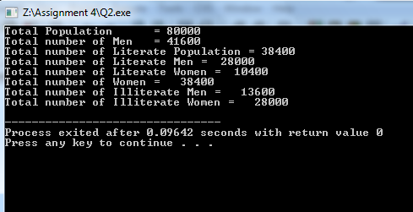

Q3) /*If the total selling price of 15 items and
the total profit earned on them is input through the keyboard. Write a program to find the cost price of one item.
*/
#include<iostream>
using namespace std;

int main()
{
float s, p, c; //s= selling price, p= profit, c= cost price

cout<<"Enter the selling price of 15 items: ";
cin>>s;
cout<<"Enter the profit on 15 items: ";
cin>>p;

//code to calculate cost of an item 'cost price = (selling price - profit)/15'
c = (s-p)/15;

cout<<"The cost price of an item is : " << c;
return 0;
}

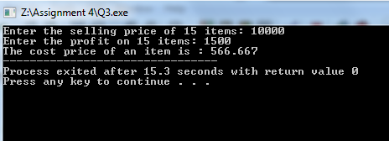

Q4) /* If a five-digit number is input through the keyboard,
write a program to print a new number by adding one to each of its digits.
For example, if the number that is input is 12391, then the output should be displayed as 23502.
*/

#include<iostream>
using namespace std;

int main()
{
int num, sum, i, number, count=0, n=1;

cout<<"Enter N Digit's Number: ";
cin>>num;

number = num;

//get the counter till then we have to run the loop

while(number!=0)
{
number = number/10;
count = count + 1;
}

for(i=1;i<count;i++)
{
n = n * 10; //n = 10
n = n + 1; //n = 11
}

sum = num + n;
cout<<sum;
}

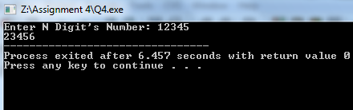

Q5) //
#include<iostream>
using namespace std;
int main()
{
float cp,sp,profit,loss;
cout<<"Enter the cost price:: ";
cin>>cp;
cout<<"Enter the selling price:: ";
cin>>sp;

if(sp>cp)
{
profit=sp-cp;
cout<<"We earn "<<profit<<" profit by selling items."<<endl;

}
else if(sp<cp)
{
loss=cp-sp;
cout<<"We incurred "<<loss<<" loss on selling items."<<endl;
}
else
cout<<"We dont get any loss and profit on selling item.";

}

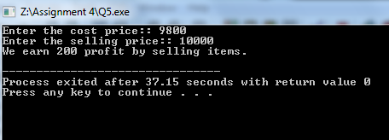

Q6) //A five digit number is entered through the keyboard

#include<iostream>
using namespace std;

int main()
{
int num,a,b,c,d,e,x;

cout<<"Enter a five digit number : ";
cin>>num;

//separating digits of the number
e = num % 10;
d = (num/10) % 10;
c = (num/100) % 10;
b = (num/1000) % 10;
a = (num/10000);

//reversing the number
x = e*10000 + d*1000 + c*100 + b*10 + a;
cout<<x;

if(x == num)
cout<<"The reverse of the number %d is same as actual number."<<num;

return 0;
}

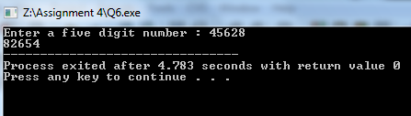

Q7) /* Write a program to check whether a triangle is valid or not,
when the three angles of the triangle are entered through the keyboard.
A triangle is valid if the sum of all the three angles is equal to 180 degrees.
*/

#include<iostream>
using namespace std;
int main()
{
int a,b,c;

cout<<"Enter the angles of a triangle in degrees : ";
cin>>a>>b>>c;

if(a+b+c == 180)
cout<<"The triangle is valid";
else
cout<<"The triangle is not valid.";

return 0;
}
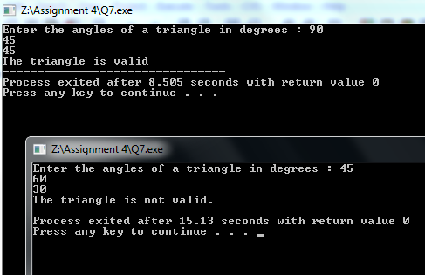

Q8) /* Given the length and breadth of a rectangle, write a program to find
whether the area of the rectangle is greater than its perimeter.
For example, the area of the rectangle with length = 5
and breadth = 4 is greater than its perimeter.
*/

#include<iostream>
using namespace std;
int main()
{
float a,b,area, peri;

cout<<"Enter the length and breadth of the rectangle : ";
cin>>a>>b;

area = a*b;
peri = 2*a + 2*b;

if(area > peri)
cout<<"The area "<<area<<" of the rectangle is greater than it's perimenter "<<peri;
else
cout<<"The area "<<area<<" of the rectangle is less than it's perimenter "<<peri;

return 0;
}

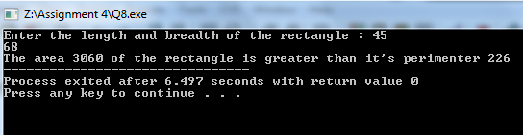

Q9) /* Given three points (x1, y1), (x2, y2) and (x3, y3),
write a program to check if all the three points fall on one straight line.
*/

#include<iostream>
using namespace std;
int main()
{
int x1,x2,x3,y1,y2,y3,ar;

cout<<"Enter x-y coordinates of first point : ";
cin>>x1>>y1;

cout<<"\nEnter x-y coordinates of second point : ";
cin>>x2>>y2;

cout<<"\nEnter x-y coordinates of third point : ";
cin>>x3>>y3;

ar= (x1*(y2-y3) + x2*(y3-y1) + x3*(y1-y2));//condition for collinear

if(!ar)
cout<<"The points are collinear.";
else
cout<<"The points are not collinear.";

//To check there's is an example (0, -2) , (2, 4) and (-1, -5).

return 0;
}

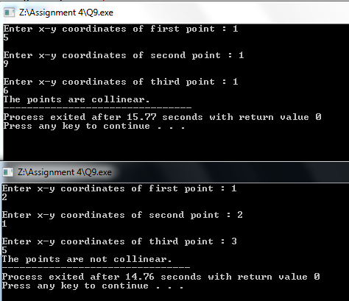

Q10) /* Given the coordinates (x, y) of a center of a circle and it’s radius,
write a program which will determine whether a point lies inside the circle,
on the circle or outside the circle.
*/

#include<iostream>
#include<cmath>
using namespace std;
int main()
{
float r,x,y;

cout<<"Enter the radius of the circle : ";
cin>>r;

cout<<" Enter the x-y coordinates of the point for checking it's position : ";
cin>>x>>y;

if(r > sqrt(pow(x,2) + pow(y,2)))
cout<<" The points lie inside the circle.";
else if(r == sqrt(pow(x,2) + pow(y,2)))
cout<<" The points lie on the circle.";
else
cout<<"The points lie outside the circle.";

return 0;
}

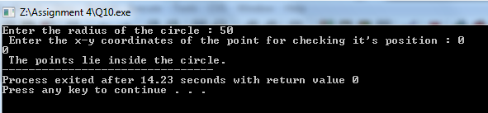

Q11) CALENDAR

#include <iostream>
#include <cstdlib>
#include <iomanip>

using namespace std;

void skip (int i)
{
while (i > 0)
{
cout << " ";
i = i - 1;
}
}

void error ()
{
cout << "\nError. End procedure." << "\n";
exit ( -1);
}

bool leap_year (int year)
{
return ((year%4==0) && (year%100 !=0))||(year%400==0) ;
}

int start_day(int year)
{
int day_start;
int x1, x2, x3;
x1 = (year - 1)/ 4;
x2 = (year - 1)/ 100;
x3 = (year - 1)/ 400;
day_start = (year + x1 - x2 + x3) %7;
return day_start;
}

int number_days_month (int m, bool leap)
{
if (m == 1) return(31);
else if (m == 2) if (leap) return(29);else return(28);
else if (m == 3) return(31);
else if (m == 4) return(30);
else if (m == 5) return(31);
else if (m == 6) return(30);
else if (m == 7) return(31);
else if (m == 8) return(31);
else if (m == 9) return(30);
else if (m == 10) return(31);
else if (m == 11) return(30);
else if (m == 12) return(31);
else error();
}

void print_month_name (int m)
{
if (m == 1)
{
skip(7);
cout << "January" << "\n";
}
else if (m == 2) { skip(7); cout << "February" << "\n"; }
else if (m == 3) { skip(7); cout << "March" << "\n"; }
else if (m == 4) { skip(7); cout << "April" << "\n"; }
else if (m == 5) { skip(7); cout << "May" << "\n"; }
else if (m == 6) { skip(7); cout << "June" << "\n"; }
else if (m == 7) { skip(7); cout << "July" << "\n"; }
else if (m == 8) { skip(7); cout << "August" << "\n"; }
else if (m == 9) { skip(7); cout << "September" << "\n"; }
else if (m == 10) { skip(7); cout << "October" << "\n"; }
else if (m == 11) { skip(7); cout << "November" << "\n"; }
else if (m == 12) { skip(7); cout << "December" << "\n"; }
else error();

cout << " S M T W T F S" <<"\n";
cout << "____________________" << "\n";
}

void print_month (int number_days, int &weekDay)
{
int day = 1;

while (day <= number_days)
{
cout << setw(2) << day << " ";
if (weekDay == 6)
{
cout << "\n";
weekDay = 0;
}
else weekDay = weekDay + 1;
day = day + 1;
}
}

int main ()
{

int year, start_day_month, number_days, current_month = 1;
bool leap;

cout << "Enter the year : ";
cin >>year;
cout<<"\n";

start_day_month=start_day(year);
leap = leap_year(year);
skip(9);

cout << year << "\n";

while (current_month <= 12)
{
number_days = number_days_month(current_month, leap);
print_month_name(current_month);
print_month(number_days, start_day_month);
cout << "\n\n\n";
current_month = current_month + 1;
}
cout << "\n";
}

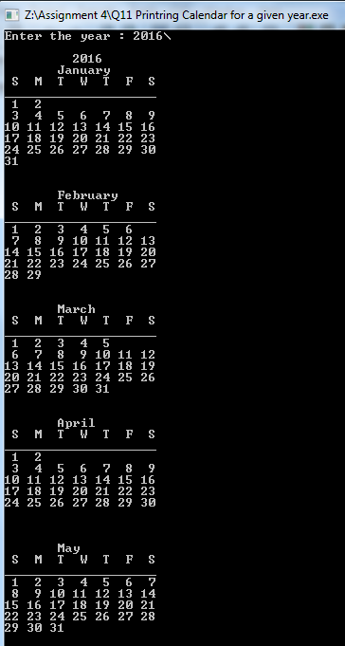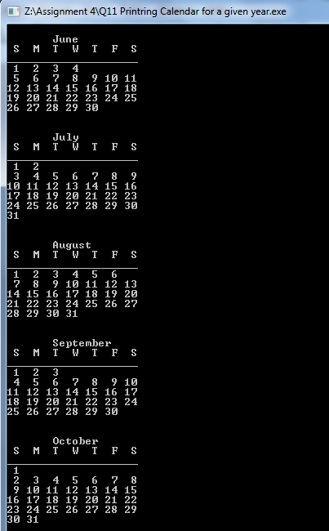

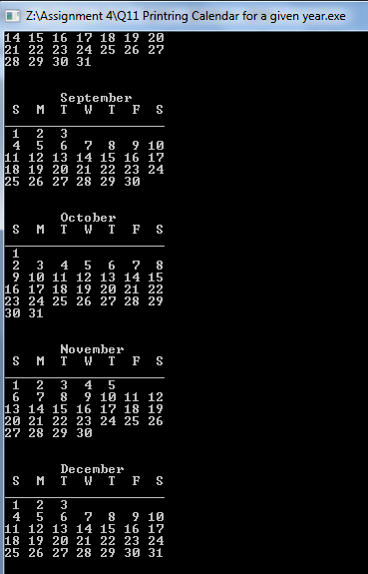

Q12) /*In a class there are n number of students – each studying m subjects.
Marks of each of the student in each of the subjects are to be read and class average
in each subject and the average of total marks in all subjects to be computed.
There is no need to store the values – No need to use arrays – Assume that m is 3 and
use sentinel -100 to end inputs. Output marks in each subject and total obtained by each student
in a row and subject average and class average in the last row.*/

#include<iostream>
using namespace std;

int Average(int, int);

int main(){
int n, m;
cout<<" Enter the Number of Students in class : ";
cin>>n;
m=3;
// cout<<"Please Enter the Number Subjects : ";
// cin>>m;
Average(n,m);
return 0;

}

int Average(int a, int b){
int i, j;
float S1,S2,S3,sub1Sum=0,sub2Sum=0,sub3Sum=0;
for(i=1;i<=a;i++){
cout<<"Please Enter marks of Student- "<<i<<" in All "<<b<<" Subjects "<<endl;
for(j=1;j<=b;j++){
if(j==1){
cin>>S1;
sub1Sum += S1;
}
if(j==2){
cin>>S2;
sub2Sum += S2;
}
if(j==3){
cin>>S3;
sub3Sum += S3;
}
}
cout<<"Average Of Student- "<<i<<" Marks ="<<(S1+S2+S3)/3<<endl<<endl;
}
cout<<"Average Of Subject-1 = "<<sub1Sum/a<<endl;
cout<<"Average Of Subject-2 = "<<sub2Sum/a<<endl;
cout<<"Average Of Subject-3 = "<<sub3Sum/a<<endl;
cout<<"Average Of All Three Subjects = "<<(sub1Sum+sub2Sum+sub3Sum)/(3*a);
return 0;
}

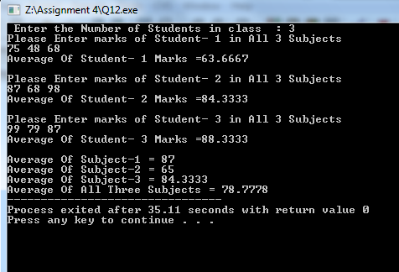

Q13) /*
Write a function to take a floating point number as input and returns the same number
rounded to k decimal places. Do not use any system defined functions.
If input is 17.24578, and k = 2, the output is 17.25 and 345.2034 is rounded as 345.20.
*/

#include<iostream>
using namespace std;

int main()
{
long double num,num1;
int n,i = 0,p = 1,numc;
cout << "Please enter a FLoating Number : ";
cin >> num;
cout << "Please enter the decimal places you want to print : ";
cin >> n; //17.6254
while(i <= n)
{
num *= 10; //17625.4
i++;
p *= 10; //1000
}
p/=10; // 100
numc = num; //17625
if(numc % 10 >= 5)
{
numc += (10-(numc % 10)); //17630
}
cout<<"Result after round off = ";
cout << (float)((float)(numc/10)/p);

}

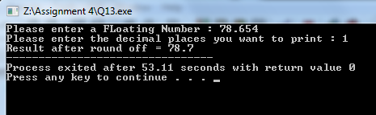

Q14) /*
Use functions to write a program to implement integer calculator with functions
add, subtract, multiply, quotient, modulus, exponent.
Provide proper user interface.
*/

#include<iostream>
#include<math.h>
using namespace std;

void add();
void subtract();
void multiply();
void quotient();
void modulus1();
void exponent();

int num1, num2;

int main(){
char operation;
cout<<"Please Choose which operation you want to Perform : "<<endl;
cout<<"\t\t|Enter + to perform Addition |"<<endl;
cout<<"\t\t|Enter - to perform Subtraction |"<<endl;
cout<<"\t\t|Enter * to perform Multiplication |"<<endl;
cout<<"\t\t|Enter / to perform Division |"<<endl;
cout<<"\t\t|Enter % to perform Modulus |"<<endl;
cout<<"\t\t|Enter ^ to perform Exponent |"<<endl;

m:
cout<<"\n\n\t\tPlease Enter the Operation You want to Perform : ";

cin>>operation;

switch(operation){
case '+':
{
add();
break;
}
case '-':
{
subtract();
break;
}
case '*':
{
multiply();
break;
}
case '/':
{
quotient();
break;
}
case '%':
{
modulus1();
break;
}
case '^':
{
exponent();
break;
}
default :
{
cout<<"\n\t\tPlease Enter the Valid Operation "<<endl;
goto m;
}
}
return 0;
}

void add(){
cout<<"\t\tPlease Enter the First Number : ";
cin>>num1;
cout<<"\t\tPlease Enter the Second Number : ";
cin>>num2;
cout<<"\t\tSum of First and Second Number : "<<num1+num2;
}

void subtract(){
cout<<"\t\tPlease Enter the First Number : ";
cin>>num1;
cout<<"\t\tPlease Enter the Second Number : ";
cin>>num2;
cout<<"\t\tDifference of First and Second Number : "<<num1-num2;
}

void multiply(){
cout<<"\t\tPlease Enter the First Number : ";
cin>>num1;
cout<<"\t\tPlease Enter the Second Number : ";
cin>>num2;
cout<<"\t\tProduct of First and Second Number : "<<num1*num2;
}

void quotient(){
cout<<"\t\tPlease Enter the First Number : ";
cin>>num1;
cout<<"\t\tPlease Enter the Second Number : ";
cin>>num2;
cout<<"\t\tDivision of First and Second Number : "<<num1/num2;
}

void modulus1(){
cout<<"\t\tPlease Enter the First Number : ";
cin>>num1;
cout<<"\t\tPlease Enter the Second Number : ";
cin>>num2;
cout<<"\t\tModulus of First and Second Number : "<<num1%num2;
}

void exponent(){
cout<<"\t\tPlease Enter the Number : ";
cin>>num1;
cout<<"\t\tPlease Enter the Exponent : ";
cin>>num2;
cout<<"\t\tResult of "<<num1<<"^"<<num2<<" is : "<<pow(num1,num2);
}

